# Chapter 1: Introduction

* Background and motivation
* Problem statement
* Scope
* Methodology
* Objectives

# Chapter 2: Market and Literature Survey

* Related works
* System features
* SWOT analysis

# Chapter 3: Analysis

* Functional requirements

1. **Register**

Allow users to register by creating new account or through their Google account.

# Login

Allow users to login using their email and password or through their Google account.

# Reset Password

Allow users to initiate a password reset through email verification.

# Edit Password

Allow users to change their passwords.

# Edit profile

Allow users to edit their profile information (image, Date of birth, Gender, first name, last name).

# Turning on/off notifications

Allow users to toggle notifications on or off.

# Select starting day time

Allow users set their preferred start time for daily activities.

# Preferences Questions

The user answers these questions (true/false) only once when using the program for the first time.

# Depression test

The user answers these questions to find out whether he has depression or not.

# Select mood

Allow users to input their daily mood and each mood has some tips to deal with it.

# Select activities and reasons:

Allow users to input their daily activities and reasons and they can add more activities or reasons.

# Journal Entries

User can write how the day was.

# Provide customize plan based on preferences

The system creates a personalized plan for the users to help them improve

# User make his plan

Allow users to select topics they are interested in to make plan

# Pick the time for meditation

Allow users to set their preferred meditation time

# Play music audios for meditation

Provide a library of meditation audio for users to play during meditation.

# Challenge thoughts

Provide types of the thought and each type has some explanation for it, Allow users to identify their thought patterns.

# View Insights

Display insights on depression, stress, activities, and weekly checking.

# Weekly Checking

Send true/false questions for weekly checking and user answer them.

# Stress detection

Identify if the user has stress or not based on journaling.

# Depression detection

Identify if the user has depression or not based on journaling.

# Chat bot

Chat bot for users to interact with.

* Non-functional requirements

1. **Usability**
   * The application has an easy-to-use interface that has everything a user needs in an easy way to understand.
   * The colors used in the application are consistent and comfortable for the eye.
2. **Robustness**
   * The system can respond and handle invalid inputs with error messages and exception handling.
3. **Security**
   * The system will show only the data related to each user.
   * No other users can access another user's data.
4. **Reliability**
   * The application shows the user a clear error message when the user fails to enter a valid command
5. **Availability**
   * The system will be available 24/7 and the user can use it at any time.
6. **Response Time**
   * The system will respond to user requests in a minimum amount of time.
7. **Memorability**
   * Colors, themes and experience in our app will be unforgettable, so users can return to the interface after some time and start efficiently working with it right away.

* Audience
* Stakeholders
* ERD
* Use case diagram

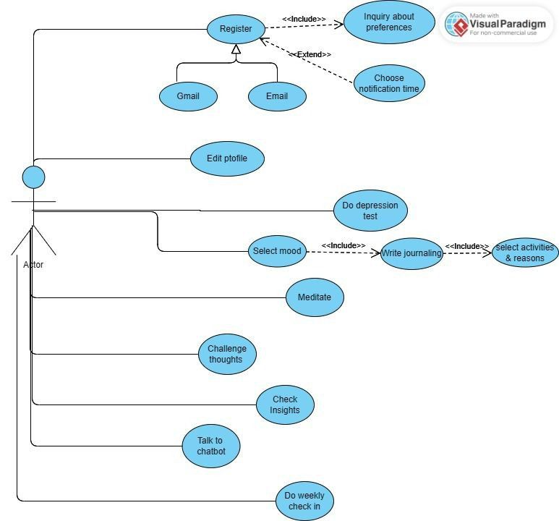

* Use case description & Sequence flows

|  |  |  |
| --- | --- | --- |
| **Use case name** | **Register with email** | |
| **Actors** | User | |
| **Description** | User register for application by entering his email, password, username, and confirm his password | |
| **Preconditions** | ----- | |
| **Post conditions** | Have account in application | |
| **Flow of activities** | Actor | System |
|  |  |
| **Exception conditions** |  | |

|  |  |  |
| --- | --- | --- |
| **Use case name** | **Register with Gmail** | |
| **Actors** | User | |
| **Description** | User register for application through Gmail | |
| **Preconditions** | ------ | |
| **Post conditions** | Have account in application | |
| **Flow of activities** | Actor | System |
|  |  |
| **Exception conditions** |  | |

|  |  |  |
| --- | --- | --- |
| **Use case name** | **Inquiry about preferences** | |
| **Actors** | User | |
| **Description** | True/false questions appear only once after user register to the application to get his preferences. | |
| **Preconditions** | The user must be registered. | |
| **Post conditions** | Store answers and then use it to help user. | |
| **Flow of activities** | Actor | System |
| Start  Answer questions  View confirmation | Send the questions  Save the answers  Send confirmation |
| **Exception conditions** | If the user didn’t fill all the question his/her data will not be saved | |

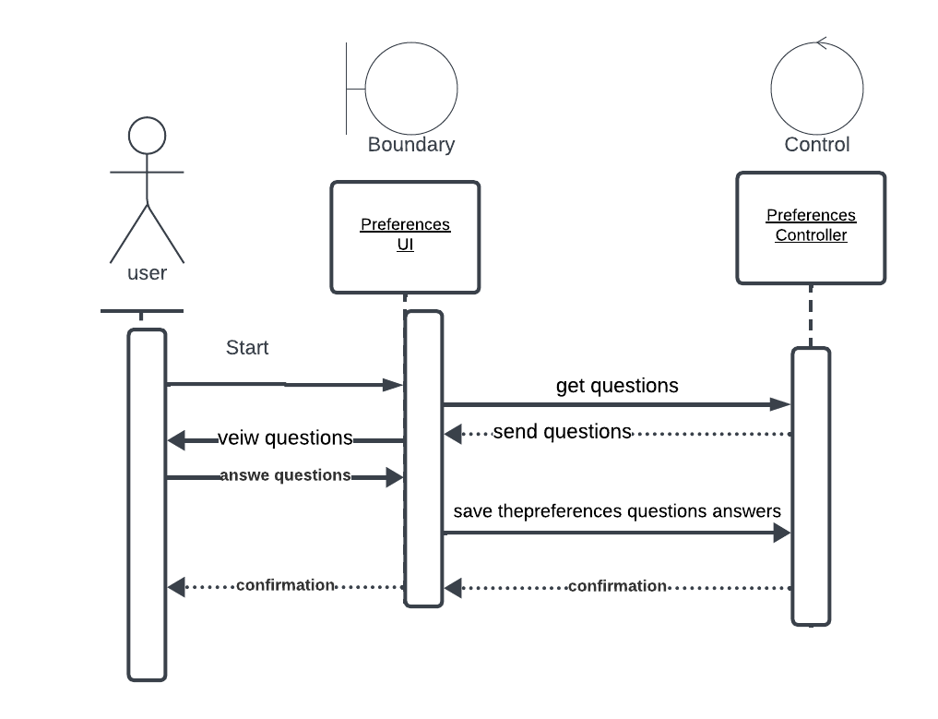

|  |  |  |
| --- | --- | --- |
| **Use case name** | **Choose notification time** | |
| **Actors** | User | |
| **Description** | The user chooses the appropriate time for the notification. | |
| **Preconditions** | The user must be registered. | |
| **Post conditions** | Sending the notification to the user at this time. | |
| **Flow of activities** | Actor | System |
| User go to the setting  User choose the time | Store the time  Send conformation |
| **Exception conditions** | No Exceptions | |

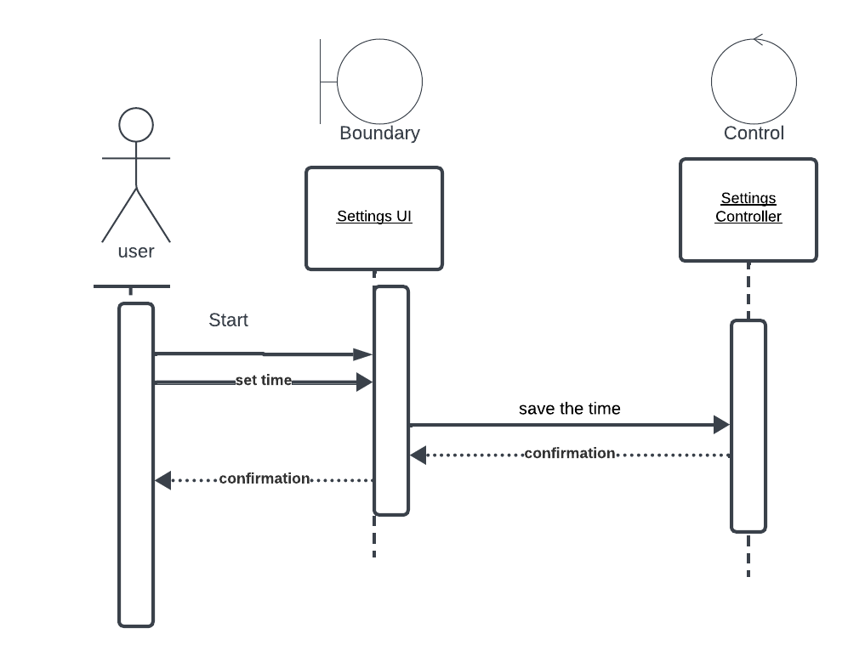

|  |  |  |
| --- | --- | --- |
| **Use case name** | **Edit profile** | |
| **Actors** | user | |
| **Description** | User edits his information such as name, email, password and his photo. | |
| **Preconditions** | User must be logged in. | |
| **Post conditions** | User account updated successfully. | |
| **Flow of activities** | Actor | System |
|  |  |
| **Exception conditions** |  | |

|  |  |  |
| --- | --- | --- |
| **Use case name** | **Do depression test** | |
| **Actors** | User | |
| **Description** | User answers these test questions to find out whether he has depression or not. | |
| **Preconditions** | User must be logged in. | |
| **Post conditions** | Depression test result. | |
| **Flow of activities** | Actor | System |
|  |  |
| **Exception conditions** |  | |

|  |  |  |
| --- | --- | --- |
| **Use case name** | **Select mood** | |
| **Actors** | User | |
| **Description** | Enabling users to express their emotional states easily by selecting emoji for their daily mood. | |
| **Preconditions** | User must be logged in. | |
| **Post conditions** | Store mood in app's database. | |
| **Flow of activities** | Actor | System |
|  |  |
| **Exception conditions** |  | |

|  |  |  |
| --- | --- | --- |
| **Use case name** | **Write journaling** | |
| **Actors** | user | |
| **Description** | User can write how was his day. | |
| **Preconditions** | User must be logged in. | |
| **Post conditions** | Analyze sentiment in this journaling to discover if there is stress or depression. | |
| **Flow of activities** | Actor | System |
|  |  |
| **Exception conditions** |  | |

|  |  |  |
| --- | --- | --- |
| **Use case name** | **select activities & reasons** | |
| **Actors** | user | |
| **Description** | users can enter their daily activities and reasons and they can add more activities or reasons. | |
| **Preconditions** | User must be logged in. | |
| **Post conditions** | Store them in app's database. | |
| **Flow of activities** | Actor | System |
|  |  |
| **Exception conditions** |  | |

|  |  |  |
| --- | --- | --- |
| **Use case name** | **Meditate** | |
| **Actors** | User | |
| **Description** | Provide a library of meditation audio for users to choose from it. | |
| **Preconditions** | User must be logged in. | |
| **Post conditions** | Lead user to greater awareness, acceptance, and a more mindful approach to daily activities.  ??? | |
| **Flow of activities** | Actor | System |
|  |  |
| **Exception conditions** |  | |

|  |  |  |
| --- | --- | --- |
| **Use case name** | **Challenge thoughts** | |
| **Actors** | user | |
| **Description** | Provide types of the thought and each type has some explanation for it. | |
| **Preconditions** | User must be logged in. | |
| **Post conditions** | users will identify their thought patterns.  ??? | |
| **Flow of activities** | Actor | System |
|  |  |
| **Exception conditions** |  | |

|  |  |  |
| --- | --- | --- |
| **Use case name** | **Check Insights** | |
| **Actors** | User | |
| **Description** | Providing users with a comprehensive view of their mental health journey in application like activities | |
| **Preconditions** | User must be logged in. | |
| **Post conditions** | View charts | |
| **Flow of activities** | Actor | System |
| Start  View charts | Send activities charts  Send depression test score chart  Send weekly check-in chart  Send stress chart |
| **Exception conditions** | No exceptions | |

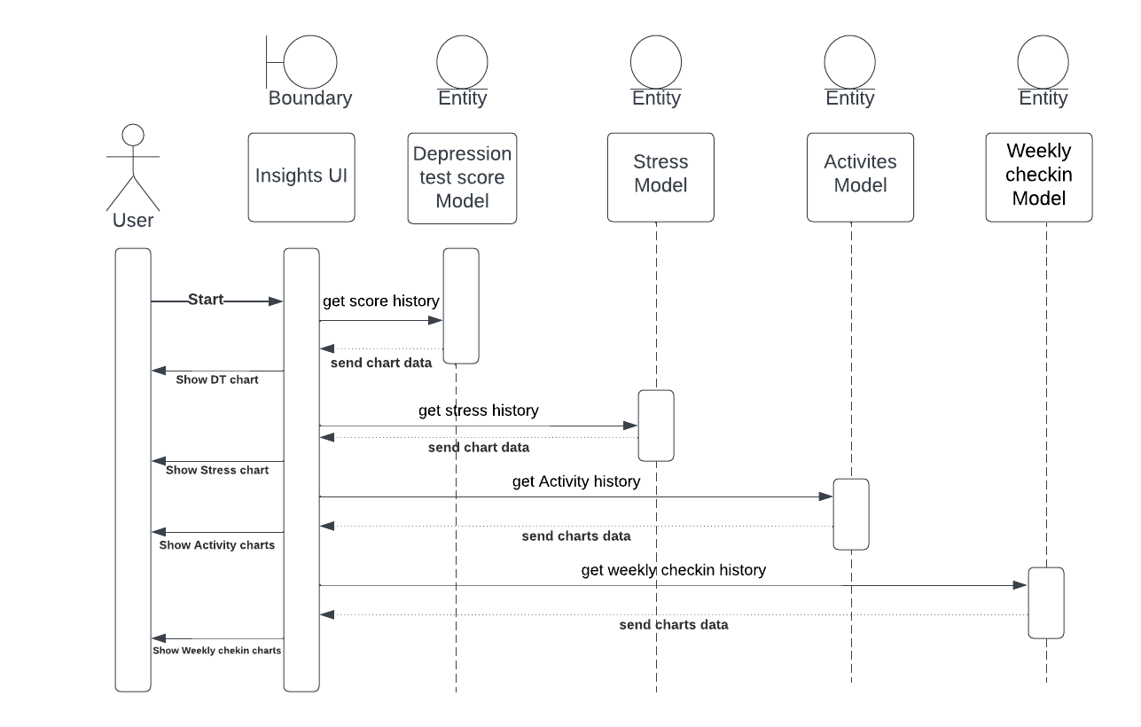

|  |  |  |
| --- | --- | --- |
| **Use case name** | **Talk to chatbot** | |
| **Actors** | User | |
| **Description** | Interactive and conversational engagement with the chatbot for mental health questions. | |
| **Preconditions** | User must be logged in. | |
| **Post conditions** | Find out the answers to his questions.  ??? | |
| **Flow of activities** | Actor | System |
|  |  |
| **Exception conditions** |  | |

|  |  |  |
| --- | --- | --- |
| **Use case name** | **Do weekly check in** | |
| **Actors** | User | |
| **Description** | true/false questions for weekly checking and user answer them. | |
| **Preconditions** | User must be logged in. | |
| **Post conditions** | Confirmation and Store it in app's database. | |
| **Flow of activities** | Actor | System |
| Start  Answer the Questions  View Confirmation | Send the questions  Save the answers  Send confirmation |
| **Exception conditions** | No Exception | |

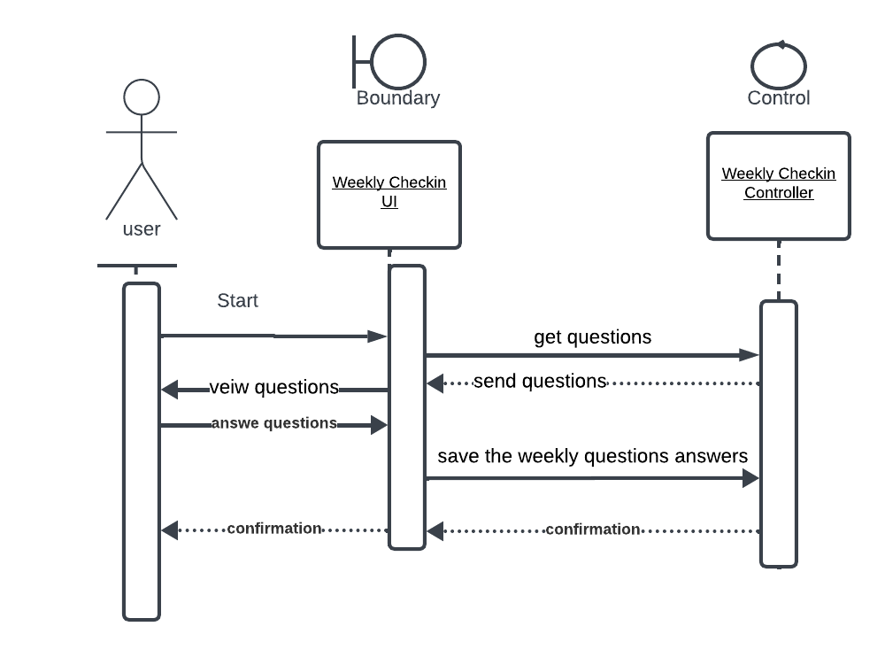

|  |  |  |
| --- | --- | --- |
| **Use case name** | **Customize plan** | |
| **Actors** | User | |
| **Description** | Customized plan for the user based on the faviourte topics. | |
| **Preconditions** | User must be logged in and did the preferences inquiry. | |
| **Post conditions** | Confirmation and customized plan. | |
| **Flow of activities** | Actor | System |
| Start  Select topics  View plan  View today task | Send the topics  Save the topics  Send activity based on the selected topics  Send daily activity task |
| **Exception conditions** | No Exception | |

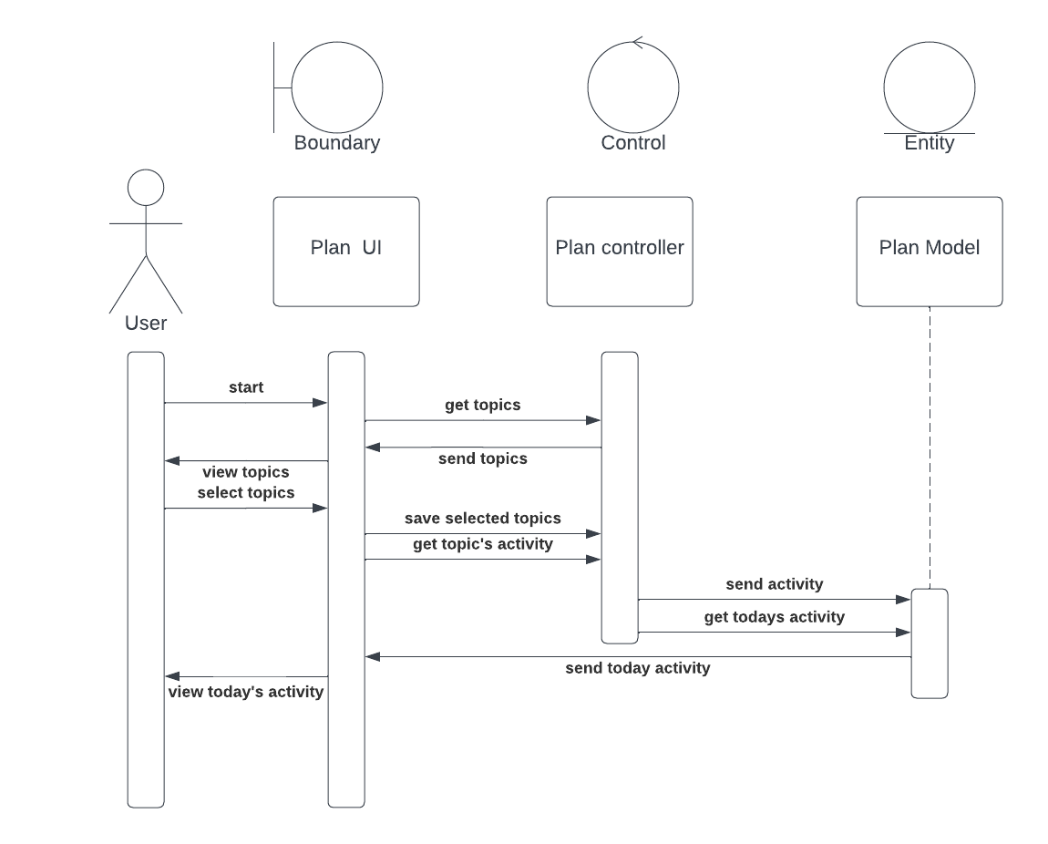

* Class diagram

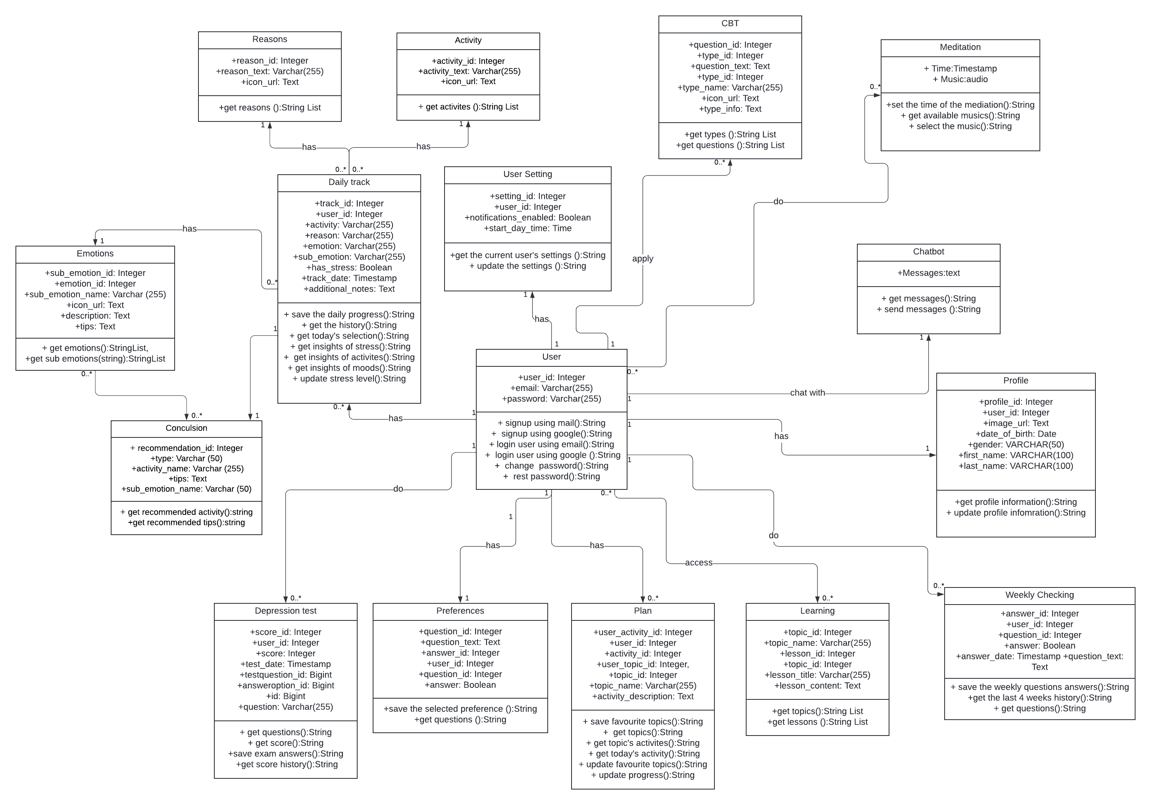

* System Architecture diagram

# Chapter 4: Design

* UI prototype (figma)
* Technologies and tools